Job Description & Person Specification
Position: Positive Behaviour Support Manager
Reports To: Director of Services & Development
Contract: Permanent
Hours Per week: 35.7
Clinical Supervision: Provided
DBS Level: Enhanced

Our Values and Behaviours
To act in accordance with “Our Values and Behaviours” at all times when delivering your role, ensuring that “Kindness”, “Respect”, “Belonging”, and “Empowerment” are fundamental to your behaviour.
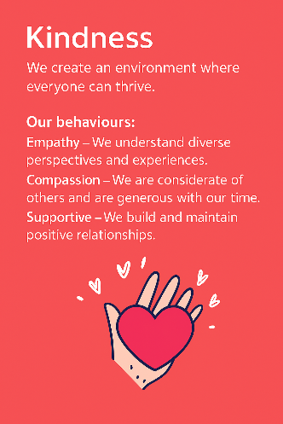
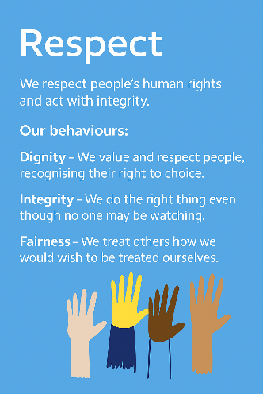
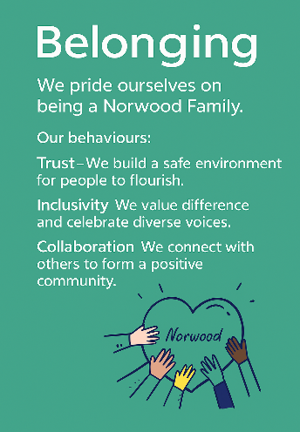
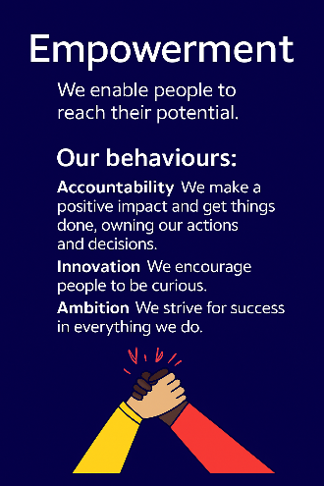
Empowerment
Respect
Belonging
Kindness

Policies and Procedures
In addition to undertaking the accountabilities as outlined below, the post holder will be expected to fully adhere to all Norwood policies and procedures which are referenced in the employment contract and Norwood's intranet.
Role Summary
As Norwood’s PBS Manager, you will provide hands-on leadership to our teams supporting children, young people and adults with complex needs. You will strengthen and modernise PBS practice across the organisation, building capability, confidence and consistency in how we deliver high-quality, person-centred support.
Your focus will be on enabling people to live fuller, more independent lives through proactive, strengths-based approaches and positive risk-taking. You will help reduce restrictive practices, improve communication and ensure support plans reflect each person’s individual strengths, needs and goals.
This role is primarily based across Ravenswood Village and our North West London services. You will be visibly present, working face to face with teams, practitioners and the people we support for the majority of the week, maintaining both operational engagement and strategic oversight.
Key Accountabilities
- Lead, coach, and develop a small team of PBS Practitioners other specialist team members, ensuring best practice and alignment with organisational quality standards.
- Foster a collaborative, supportive team culture focused on mutual support, problem solving, and continual professional development.
- Act as Norwood’s PBS subject matter expert, guiding local teams to deliver consistent, effective PBS practice.
- Oversee the monitoring and analysis of behaviours of concern, using data to inform proactive strategies and reduce the need for physical interventions.
- Provide tools, coaching, and guidance to enable teams to deliver approaches rooted in functional assessment, respecting the choices and needs of individuals supported.
- Work collaboratively with practitioners and operational teams to create high-quality, tailored PBS plans.
- Lead and deliver engaging, high-quality PROACT SCIP and PBS training to empower and upskill support teams.
- Evaluate the impact of training on support quality, staff confidence, and reductions in restrictive practices.
- Review incidents regularly, identifying trends and producing improvement recommendations to enhance quality and safety.
- Build strong relationships across Norwood, promoting personalised, strengths-based approaches to support.
- Produce high-quality, insightful written reports for internal and external audiences.
Expected Outcomes
In this role you will ensure:
- Support teams feel empowered and confident, consistently delivering PBS-aligned, high-quality support.
- Incidents of behaviours of concern and restrictive practices reduce over time.
- Staff skills, resilience, and confidence improve across Ravenswood and beyond.
- High-quality assessments and PBS plans are in place and tailored to individuals’ needs and preferences.
- Feedback from regulators reflects effective practice, high standards, and a commitment to quality.
Person Specification
 | Essential | Desirable | Evidence
Qualification(s) | - Psychology degree  - BTEC PBS Qualification  - Diploma in Applied Psychology of Learning Disabilities/Challenging Behaviour  - PBS or Behaviour Analysis accredited training (e.g., professional diploma, BSc PBS, MSc ABA/PBS)  - Willingness to complete PBS and PROACT SCIP instructor training | - PBS qualification  - PROACT SCIP instructor trained | Cover Letter / CV / Onboarding
Experience | - Developing PBS strategies and personalised support plans.  - Leading teams to deliver personalised support that reduces behaviours of concern and minimises restrictive interventions.  - Delivering engaging PROACT SCIP and PBS training.  - Working with people with Learning Disabilities, Autism, or behaviours of concern.  - Writing detailed reports for internal/external use.  - Working with regulatory bodies (e.g., CQC) to achieve “Good” or “Outstanding” outcomes. | - Experience managing teams supporting Autistic people, people with Learning Disabilities or behaviours of concern. | CV / Interview / Onboarding
Knowledge & Training | - Advanced understanding of PBS and PROACT SCIP principles. | - | Cover Letter / CV / Interview
Personal Qualities & Attributes |  |  | Cover Letter / CV / Interview
All roles require a DBS check and satisfactory clearance under Norwood’s safer recruitment policies. We are committed to safeguarding the wellbeing of our people and maintaining a respectful, safe environment.
This job description is not exhaustive and may be updated as accountabilities evolve.

